Retail Sales Analytics Report

Prepared by: Diana Banuelos-Ramirez
June 2026

Table of Contents

Section | Page
Introduction | 3
Dataset Overview | 3
Data Cleaning and Preparation | 4
Summary Statistics | 4
Outlier Analysis | 5
Correlation Analysis | 6-7
Regression Analysis | 6
Error Analysis | 7
Conclusions | 8
References | 8

Introduction
The purpose of this project was to analyze a retail sales dataset using Excel and AI-assisted analysis techniques. The dataset contains customer demographic information, purchasing behavior, item ratings, discounts, and purchase history. The objective was to identify trends, detect outliers, evaluate relationships among variables, and build a predictive model using linear regression.

Dataset Overview
The Retail Sales dataset contains 5,000 customer records and includes both numerical and categorical variables.

Numerical Variables
- Age
- Purchase Amount
- Item Rating
- Discount Applied
- Previous Purchases

Categorical Variables
- Gender
- Category
- Item Purchased
- Season
- Payment Method

The dataset met the project requirements because it contained a mix of numerical and categorical fields and provided enough observations for meaningful analysis.

Data Cleaning and Preparation
The dataset was reviewed and prepared for analysis.
The cleaning process included:
- Verifying column names and data types
- Organizing variables into numerical and categorical groups
- Removing formatting inconsistencies
- Preparing the data for descriptive statistics, correlation analysis, and regression analysis
The cleaned dataset was stored in the Clean Data worksheet and used for all subsequent analyses.

Summary Statistics
Table 1 presents descriptive statistics for the numerical variables included in the dataset.
Variable | Mean | Median | Min | Max | Count | Std. Dev
Age | 45.22 | 45 | 20 | 70 | 5000 | 14.56
Purchase Amount | $285.09 | $122.49 | $5.08 | $2,997.94 | 5000 | 551.45
Item Rating | $3.78 | $3.80 | $1.10 | $5.00 | 5000 | 0.68
Discount Applied | $14.98 | $15.00 | $0.00 | $36.00 | 5000 | 5.99
Previous Purchases | $5.01 | $5.00 | $0.00 | $13.00 | 5000 | 2.19

Key Findings
- The average customer age was 45.22 years.
- The average purchase amount was $285.09.
- The average item rating was 3.78 out of 5.
- The average discount applied was 14.98%.
- Customers averaged approximately 5 previous purchases.
The purchase amount showed the greatest variability among all variables, indicating a wide range of spending behavior across customers.

Outlier Analysis
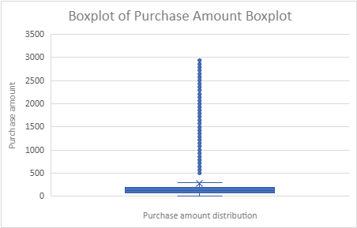
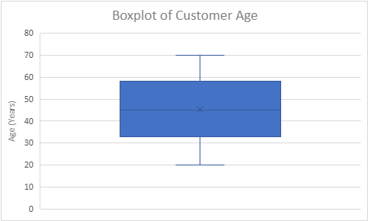
Boxplots were created to identify potential outliers and evaluate the distribution of each numerical variable.
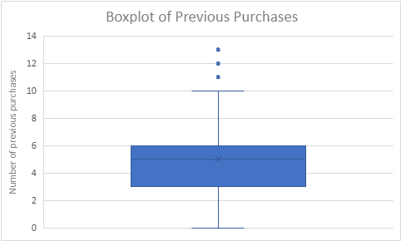
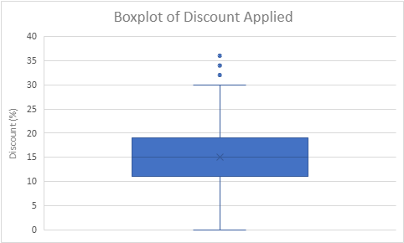
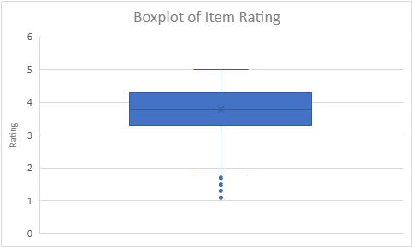

Findings (Boxplots)
- Purchase Amount contained numerous high-value outliers.
- Customer Age displayed a relatively balanced distribution.
- Item Rating showed limited variation because ratings were concentrated between 3 and 5.
- Discount Applied displayed moderate variability.
- Previous Purchases contained several higher-value observations that appeared as outliers.

The boxplots provided a visual representation of the spread and distribution of each variable.

Correlation Analysis
A correlation matrix and heatmap were generated to identify relationships among the numerical variables.
Variable | Age | Purchase Amount | Item Rating | Discount Applied | Previous Purchases
Age | 1.00 | 0.00 | 0.00 | 0.03 | 0.03
Purchase Amount | 0.00 | 1.00 | 0.00 | 0.00 | -0.01
Item Rating | 0.00 | 0.00 | 1.00 | 0.16 | 0.12
Discount Applied | 0.03 | 0.00 | 0.16 | 1.00 | 0.73
Previous Purchases | 0.03 | -0.01 | 0.12 | 0.73 | 1.00

Findings
The strongest positive relationship was observed between:
Previous Purchases and Discount Applied (r = 0.73)
This indicates that customers with more prior purchases generally received larger discounts.
Most other variable relationships were weak, suggesting that they are largely independent of one another.

Regression Analysis
A simple linear regression was performed using:
- Independent Variable (X): Previous Purchases
- Dependent Variable (Y): Discount Applied

The purpose of this analysis was to determine whether previous purchase history could predict discount levels.
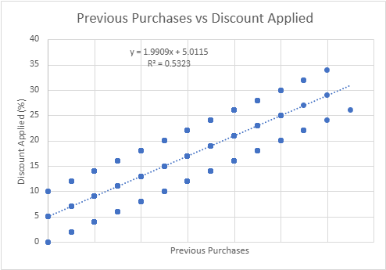

Regression Equation
y = 1.9909x + 5.0115

Coefficient of Determination (R²)
R² = 0.5323
This indicates that approximately 53.23% of the variation in Discount Applied can be explained by Previous Purchases.

Error Analysis
To evaluate the accuracy of the regression model, two error metrics were calculated: Root Mean Squared Error (RMSE) and Standard Error of Estimate (STEYX).
The RMSE value was 4.094929, while the STEYX value was 4.095749. These values indicate a moderate level of prediction error, meaning the regression model provides reasonably accurate estimates of Discount Applied based on Previous Purchases. Overall, the model demonstrates acceptable predictive performance and supports the relationship identified between the two variables.

Conclusions
The Retail Sales dataset provided valuable insight into customer purchasing behavior.
Major findings include:
- Purchase Amount displayed the greatest variability and contained numerous outliers.
- Previous Purchases and Discount Applied exhibited the strongest positive relationship.
- Customers with more purchase history tended to receive larger discounts.
- The regression model explained approximately 53% of the variation in discount levels.
- RMSE and STEYX values indicated a moderate level of prediction accuracy.

Overall, the analysis successfully identified meaningful patterns within the retail dataset and demonstrated the use of descriptive statistics, correlation analysis, visualization techniques, and predictive modeling in Excel.

References
Retail Sales Dataset obtained from Kaggle for educational analysis purposes.
Retail Store Sales

